Destiny McClain

Professor Michael Spivey

COGS 104

17 April 2020

Assignment 11: Unsupervised Hebbian Network

clear

g=0.15;

Inputs=[1 1 1 0 0 0 0 0 0;

0 0 1 1 1 0 0 0 0;

0 0 0 0 1 1 1 0 0;

0 0 0 0 0 0 1 1 1];

W=rand(9,4);

W=W./sum(W);

for epoch=1:200

for n=1:4

In=Inputs(n,:);

Output=(In\*W);

[value winner]=max(Output);

W(:,winner)=W(:,winner)+(g\*(In/sum(In))')-g\*W(:,winner);

end

end

W

Run 1: Run 2:

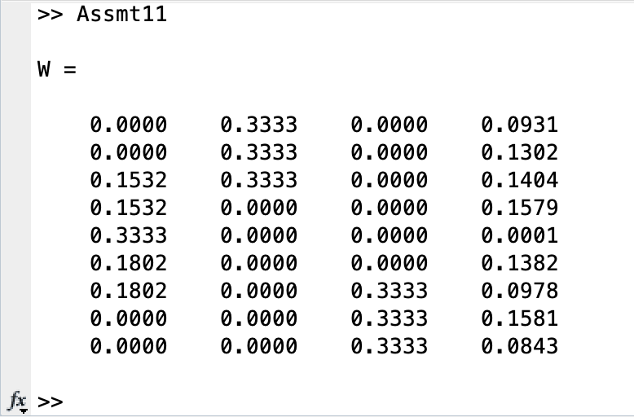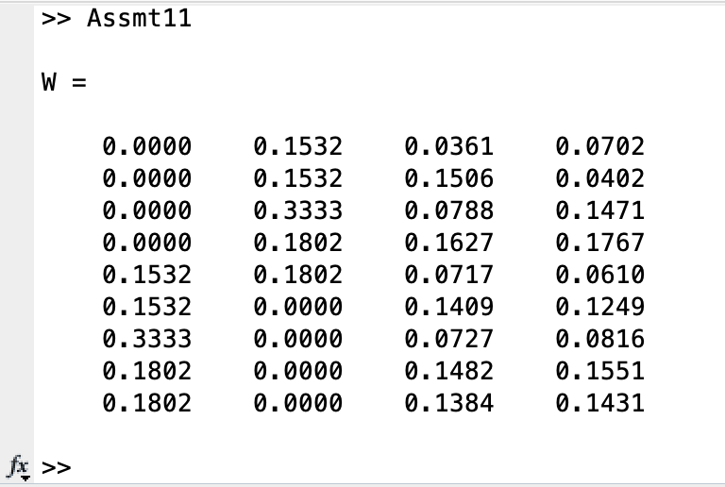

Run 3:

